Ideation Phase Empathize & Discover

Date | 20 october 2026
Team ID
Project Name | StaffSync
Maximum Marks | 4 Marks

Empathy Map Canvas:
Understand the needs, frustrations, and behaviors of freelance professionals s
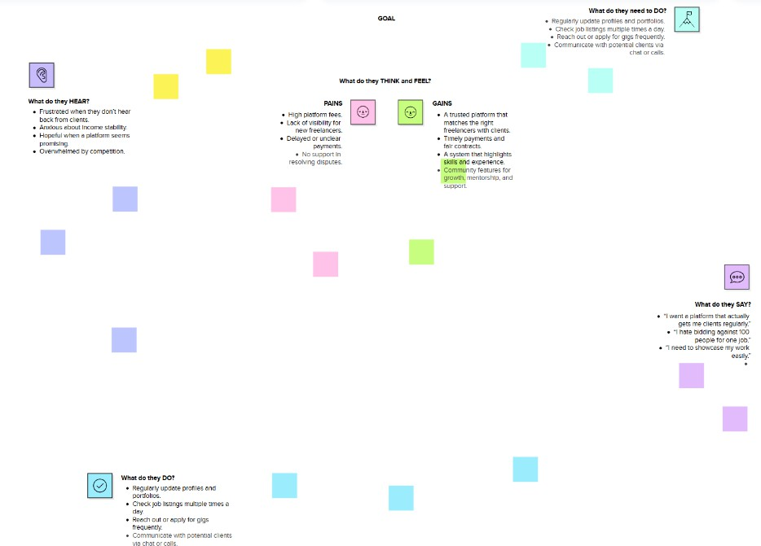
seeking consistent work through a platform like SattfSync

GOAL

Establish a modern, centralized, role-based Human Resource Management (HRM) platform that digitizes core organizational functions—eliminating manual paperwork, automating leave and attendance workflows, and fostering transparent communication across departments.

👂 What do they HEAR?

- Management requesting prompt, error-free attendance and staffing summaries.
- Employees asking: "Has my leave request been reviewed by my manager yet?"
- Complaints regarding missed policy memos or outdated employee directories.
- HR teams warning about manual calculation errors during monthly payroll prep.
- Peers discussing how automated self-service portals save hours each week.

🧠 What do they THINK and FEEL?

PAINS:
  - Frustration from repetitive data entry across multiple static Excel sheets.
  - Lack of real-time visibility into who is currently clocked in or out.
  - Communication bottlenecks when urgent leave approvals stall in inbox clutter.
  - Security concerns regarding role access and sensitive personnel data.

GAINS:
  - A single, dedicated portal tailored precisely to their organizational role.
  - Peace of mind knowing attendance and leaves are stored securely in real time.
  - Instant clarity on leave balances, pending reviews, and active company notices.
  - Faster onboarding and structured skill development for team growth.

Reference: https://www.mural.co/templates/empathy-map-canvas

